VIETNAM INTERNATIONAL UNIVERSITY – HO CHI MINH CITY

INTERNATIONAL UNIVERSITY

**WEB APPLICATION DEVELOPMENT PROJECT**

**ONLINE WATCH ANIME WEB**

By

Phạm Đông Hải - Student ID: ITITWE20023

Nguyễn Triều Vỹ - Student ID: ITCSIU21157

Advisor: Dr. Nguyen Van Sinh

A report submitted to the School of Computer Science and Engineering

in partial fulfillment of the requirements for the Final Project

in Web Application Development course – semester 2- 2024

Ho Chi Minh city, Vietnam, 2024

Contents

I. INTRODUCTION 2

1. ABOUT US 2

2. THE PRODUCT’S INFORMATION 2

3. DEVELOPMENT ENVIRONMENT 3

II. REQUIREMENT ANALYSIS AND DESIGN 4

1. Use Case diagram 4

2. Database design 5

III. IMPLEMENTATION 9

IV. DISCUSION AND CONCLUSION 16

V. REFERNCES 17

Advisor: Dr. Nguyen Van Sinh

A report submitted to the School of Computer Science and Engineering

in partial fulfillment of the requirements for the Final Project

in Web Application Development course – semester 2- 2024

Ho Chi Minh city, Vietnam, 2024

# INTRODUCTION

This section briefly introduces the background information of our software development team HV-Movie. More importantly, the basic information about our project is also mentioned in this part. Furthermore, the constraints during our project are included at the end of this section.

## ABOUT US

HV-Movie is a small programming group consisting of two members, established to complete the final project for the WAD course. Our team specializes in web application development. We always strive to find the best web-based solutions in all aspects of performance, design, and efficiency on the web platform to satisfy our customers.

|  |  |  |
| --- | --- | --- |
| Name | Phạm Đông Hải | Nguyễn Triều Vỹ |
| Student ID | ITITWE20023 | ITCSIU21157 |
| Phone | 0914717956 | 0909548571 |
| Email | Phamdonghai.t1.15cla@gmail.com | trieuvy752003@gmail.com |

## THE PRODUCT’S INFORMATION

Nowadays, watching movies online is becoming increasingly popular and valuable in Vietnam. Due to the convenience and quality of online streaming in modern life, more and more families want to have access to online movie platforms to enjoy entertainment at home.

HV-Movie is a prestigious online platform that has established a solid reputation for providing a vast library of movies for family use and entertainment. Due to the growing demand from customers who want a simplified way to watch and access movies using a web platform, we have developed an online movie streaming system to meet that demand. Our system helps people choose and watch movies more easily, quickly, and conveniently.

With our solution, users can select and watch movies from the comfort of their homes through interactions with our web-based system on both computer and mobile platforms. Specifically, our website offers some new features compared to previous versions, such as allowing customers to review and comment directly in the movie section or check the availability of upcoming releases.

## DEVELOPMENT ENVIRONMENT

Since this is a web-based product, the project is conducted using some Web Design and Programming Language. The following Programming Languages are used within our system:

1. HTML: to create an outline of the webpages

2. Tailwind CSS: to design the look of the webpages

3. JavaScript (ReactJS): to create animations and build the user interface

4. NodeJS: to handle server-side operations and build APIs

5. MySQL: to store the database of the system

Moreover, our group has also utilized cloud tools such as Google Docs to make it easier to incorporate the works of all the members in the team. Here is the link of our shared Google Drive used in this project:

We also use UML tools to help us draw Entity Relationship Diagram as well as Use Case needed in the project such as: Draw.io.

Moreover, we also make use of Visual Studio Code and GitHub- Management Tool - to keep track of the overall progress as well as each team member’s work performance.

# REQUIREMENT ANALYSIS AND DESIGN

## Use Case diagram

• User **Registration and Authentication**

* **Description**: Users should be able to register and log in to the system.
* **Actors**: User, Admin
* **Use Cases**: Register, Login, Logout

• Browse **and Search Movies**

* **Description**: Users should be able to browse and search for movies.
* **Actors**: User, Admin
* **Use Cases**: Browse Movies, Search Movies

• View **Movie Details**

* **Description**: Users should be able to view details of a specific movie.
* **Actors**: User, Admin
* **Use Cases**: View Movie Details

• Watch **Movies**

* **Description**: Registered users should be able to watch movies.
* **Actors**: User
* **Use Cases**: Watch Movies

• Manage **Movies**

* **Description**: Admins should be able to manage movies.
* **Actors**: Admin
* **Use Cases**: Add Movie, Update Movie, Delete Movie

• Logout

* **Description**: Users and Admins should be able to log out of the system.
* **Actors**: User, Admin
* **Use Cases**: Logout

## Database design

* 1. diagram

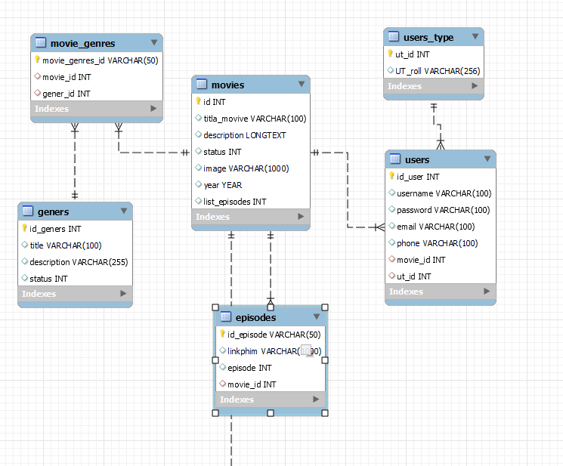

* 1. Relationship
     + The Movie table has a one-to-many relationship with the Episode and Users tables through the foreign key movie_id.

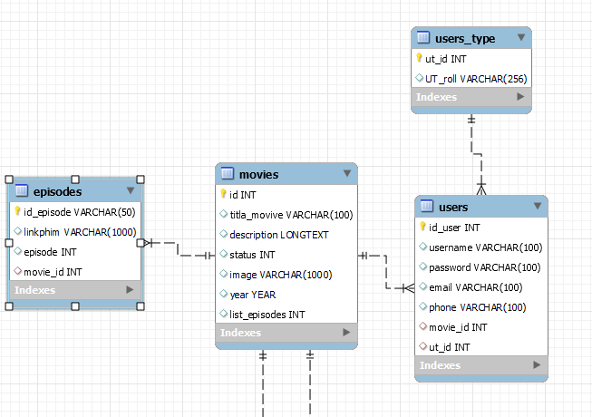

* + - The Movie table has a many-to-many relationship with the genres table, so we add sub-table movie_geners.

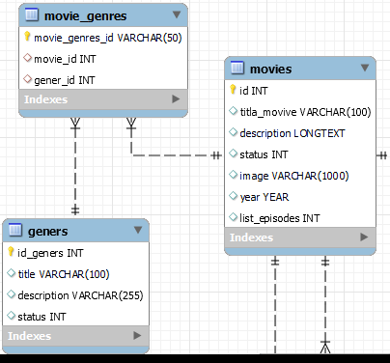

* 1. Entity Relaationships

• Entities:

* **Movie**: Represents the movie entity with attributes such as id, title, description, status, image, year, and list_episodes.
* **Episode**: Represents the episodes of a movie with attributes such as id_episode, linkphim, episode, and movie_id.
* **Genre**: Represents movie genres with attributes such as id_geners, title, description, and status.
* **MovieGenre**: Represents the association between movies and genres with attributes such as movie_genres_id, movie_id, and gener_id.
* **User**: Represents a user with attributes such as id_user, username, password, email, phone, movie_id, and ut_id.
* **UserType**: Represents user types with attributes such as ut_id and UT_roll.
* **Admin**: Inherits from **User** and has additional methods for managing movies.

• Relationships:

* **Movie** to **Episode**: One-to-Many relationship, a movie can have multiple episodes.
* **Movie** to **Genre**: Many-to-Many relationship represented by the **MovieGenre** class.
* **User** and **Admin**: Users have various functionalities like registration, login, search, view details, watch movies, and manage favorites. Admins have additional functionalities like adding, updating, and deleting movies.

# IMPLEMENTATION

The user list has normal user and admin, admin cannot be deleted from the list.

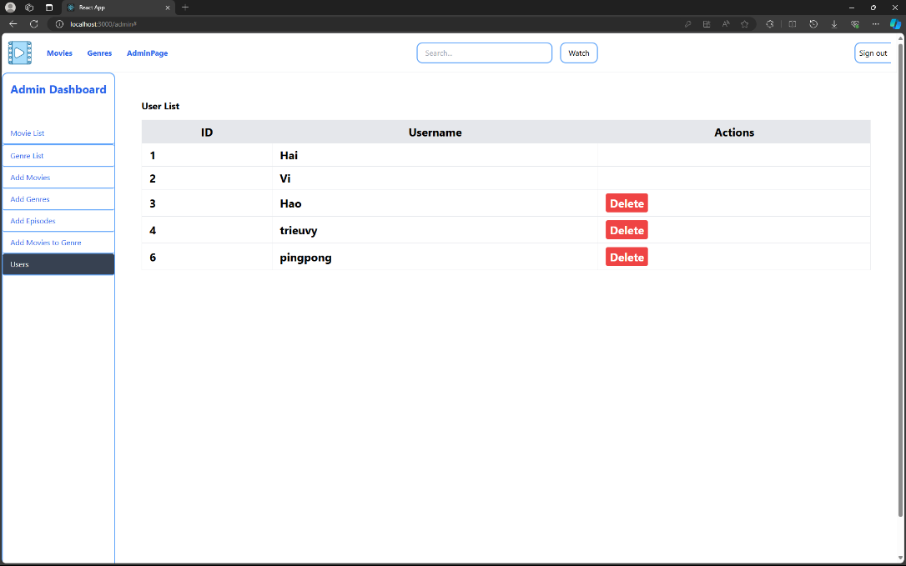

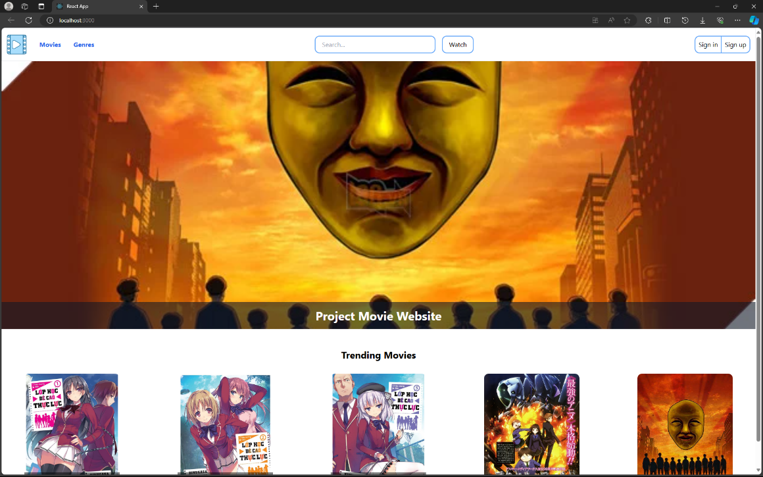

User registration and login process

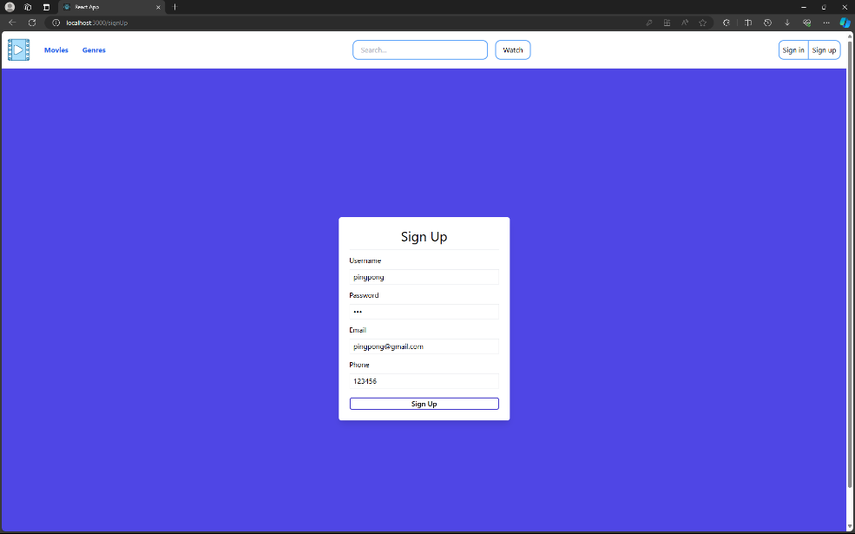

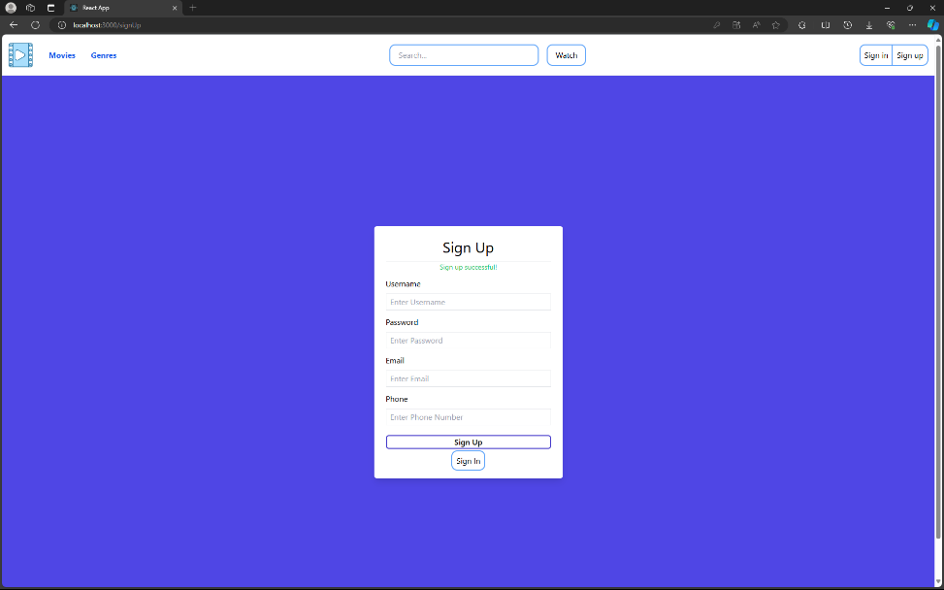

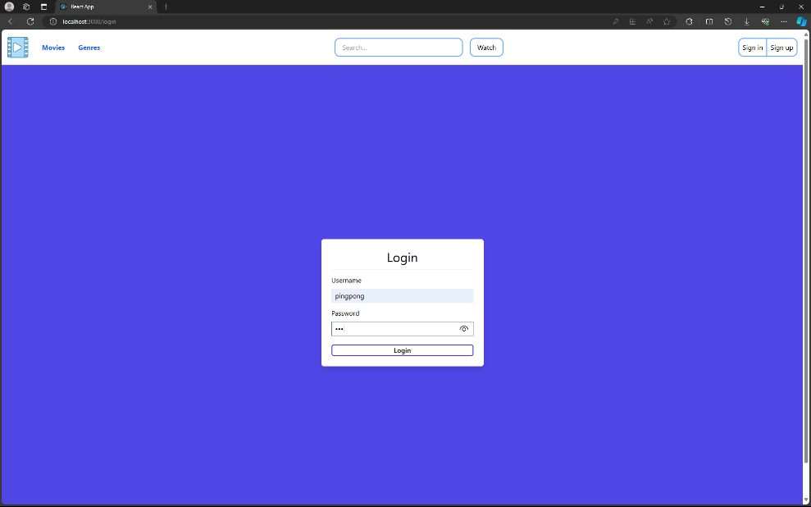

Home page and steps to watch movies

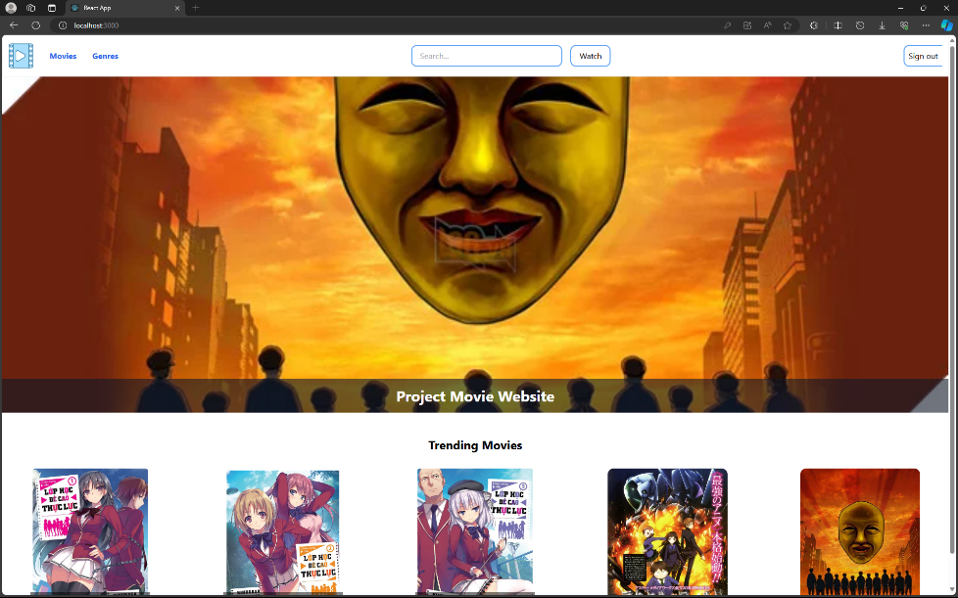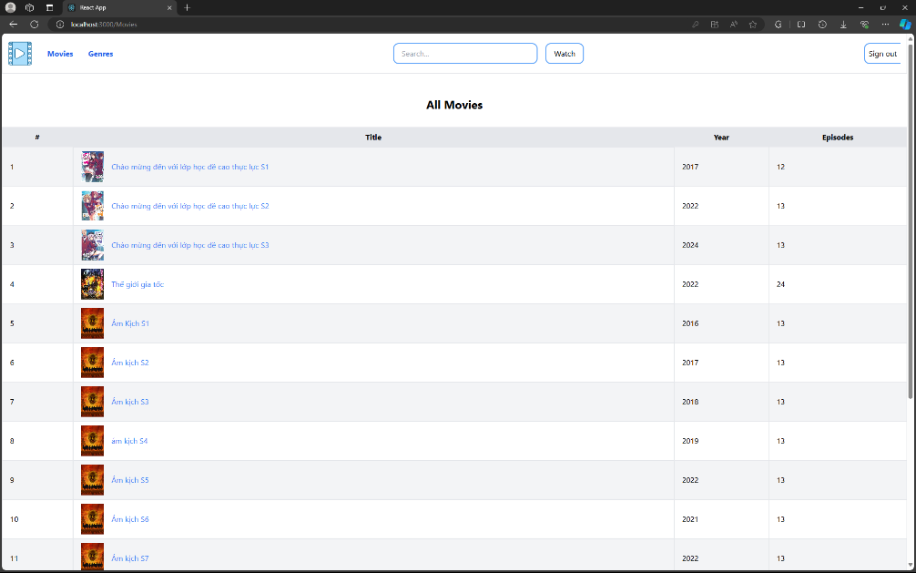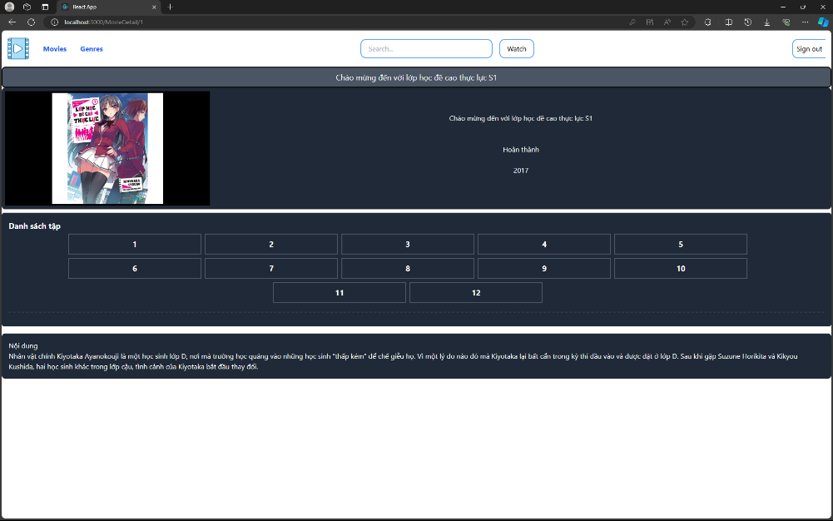

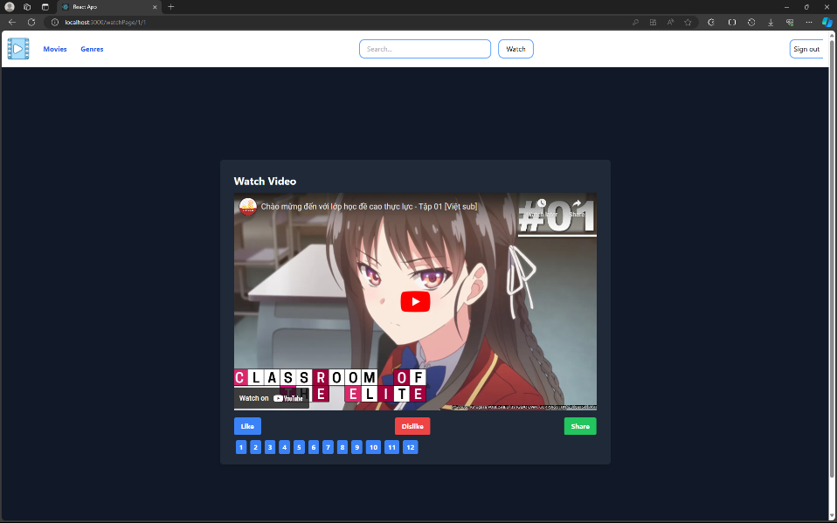

Search by movie name

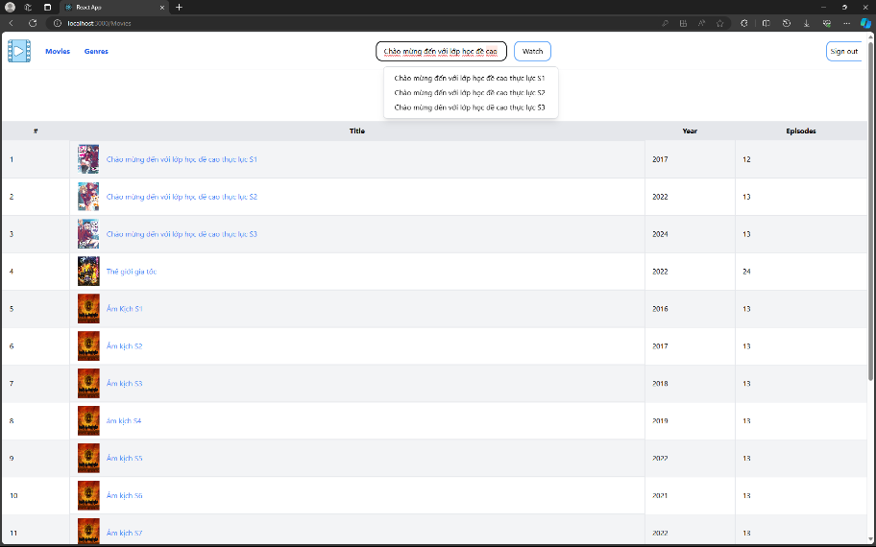

Filter movies by genre

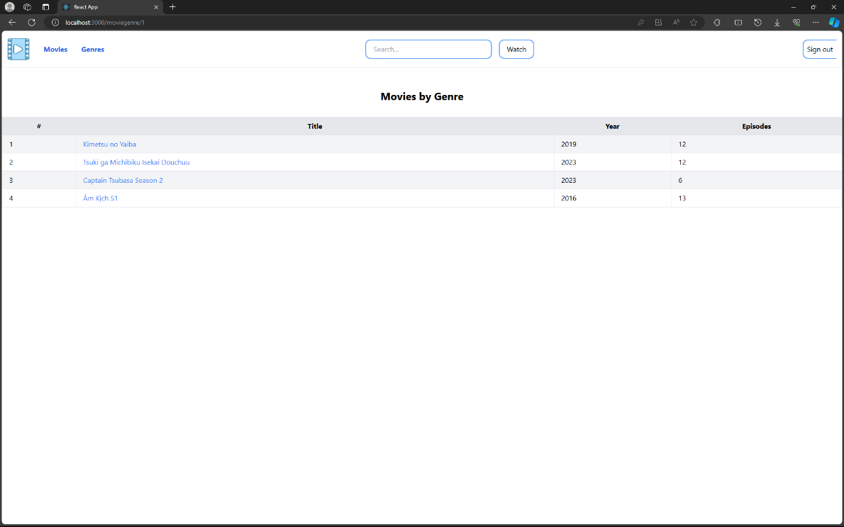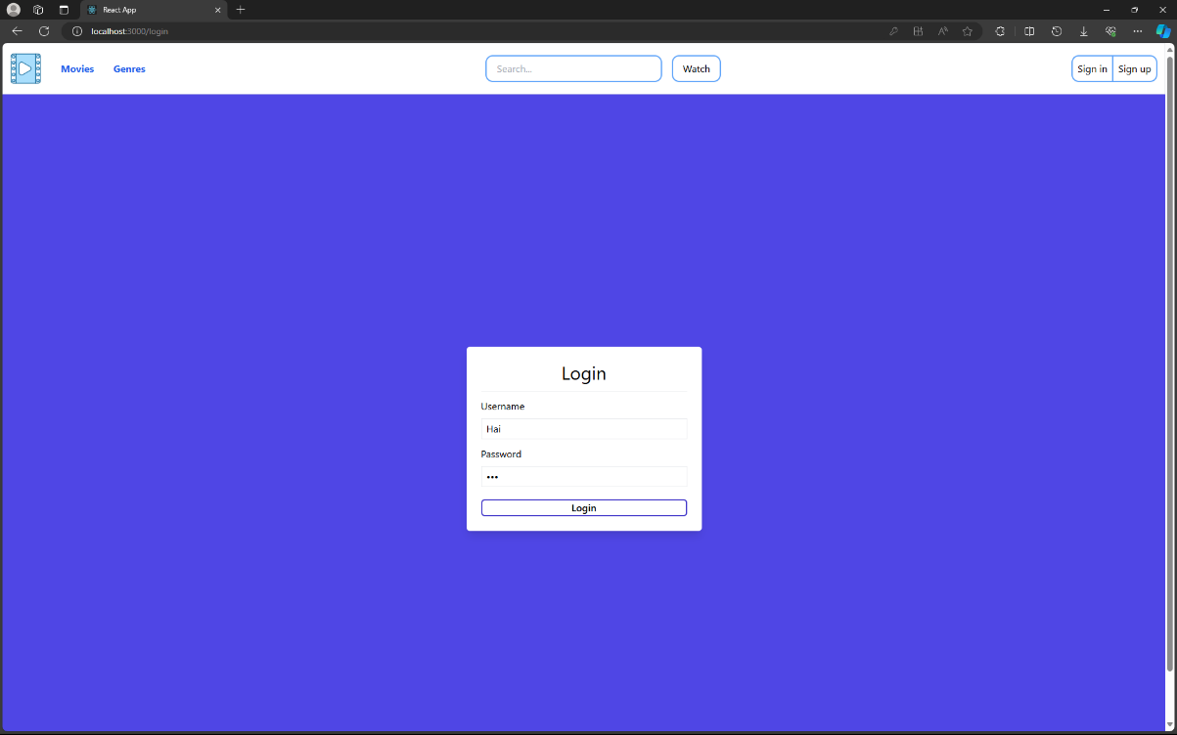

Login admin and admin features

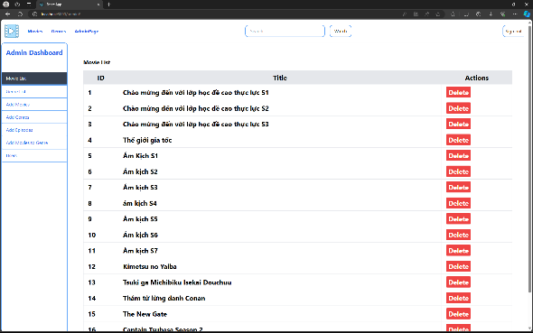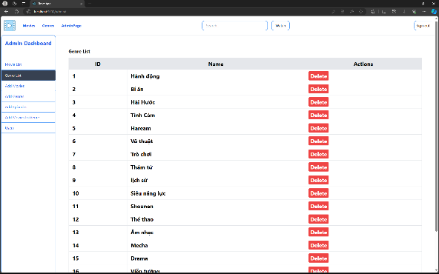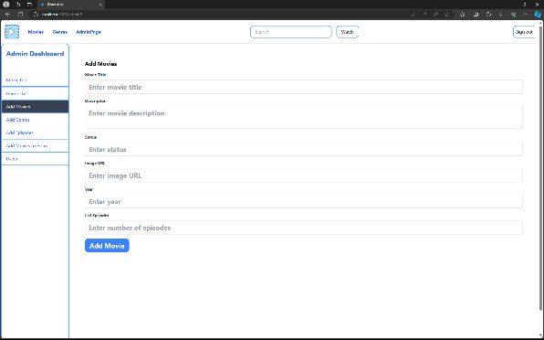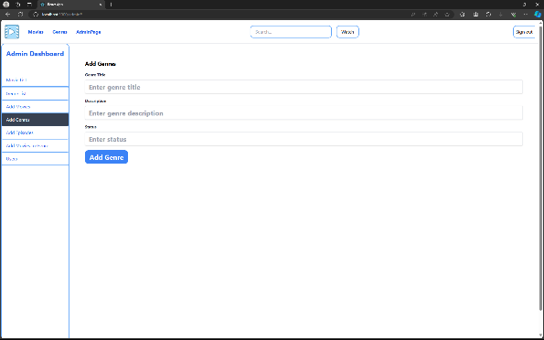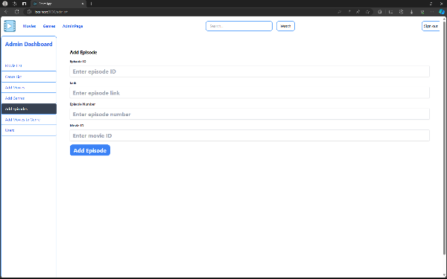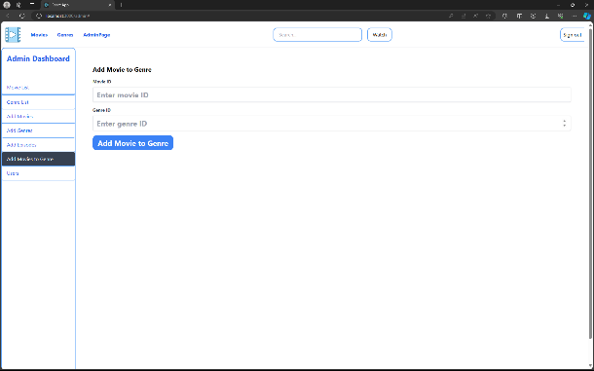

# DISCUSION AND CONCLUSION

The Online Movie Streaming Project helps us understand more clearly about the Web Application Development Process. As the current project has finished, there are some extensions we can continue to improve and develop as future works.

Firstly, the system will be more attractive and effective if we add the feature of movie comments, allowing users to leave reviews and discuss movies. This way, the system enhances user engagement and builds a community of movie enthusiasts. Secondly, introducing a donation feature can help support the platform's maintenance and development, allowing users to contribute financially to keep the service running and improving. Lastly, implementing a membership system will enable users to access the latest movies exclusively, providing an incentive for users to subscribe and gain special benefits.

Another point in this matter is that through the Online Movie Streaming Project, we have learned a lot from the current and previous works. Firstly, the skills of coding and organizing the source code in the project have improved considerably. This key aspect will help us in maintaining and developing the system over a long time, even in the future. Next, the project helps us gain the skills of analyzing and figuring out the system's requirements into a sketch version of implementation before writing the first piece of code. Finally, by working on a large system like this, the communication and teamwork skills among the members have improved significantly. This helps us easily interact and exchange ideas with each other.

As mentioned above, the Online Movie Streaming Project is an opportunity for us to learn and practice what we have learned in the course. Furthermore, we also gain valuable experience and skills during the working time.

# REFERENCES

HTML, CSS

[W3Schools Online Web Tutorials](https://www.w3schools.com/)

1. ReactJS

[Quick Start – React](https://react.dev/learn)

1. NodeJS

[Node.js — Introduction to Node.js (nodejs.org)](https://nodejs.org/en/learn/getting-started/introduction-to-nodejs)

1. Database MySQL

[MySQL :: MySQL Workbench](https://www.mysql.com/products/workbench/)

1. Text data and image data

[(1) Muse Việt Nam - YouTube](https://www.youtube.com/c/MuseVi%E1%BB%87tNam)